***The graphs below give information about computer ownership as a percentage of the population between 2002 and 2010, and by level of education for the years 2002 and 2010.  
Summarise the information by selecting and reporting the main features, and make comparisons where relevant.***

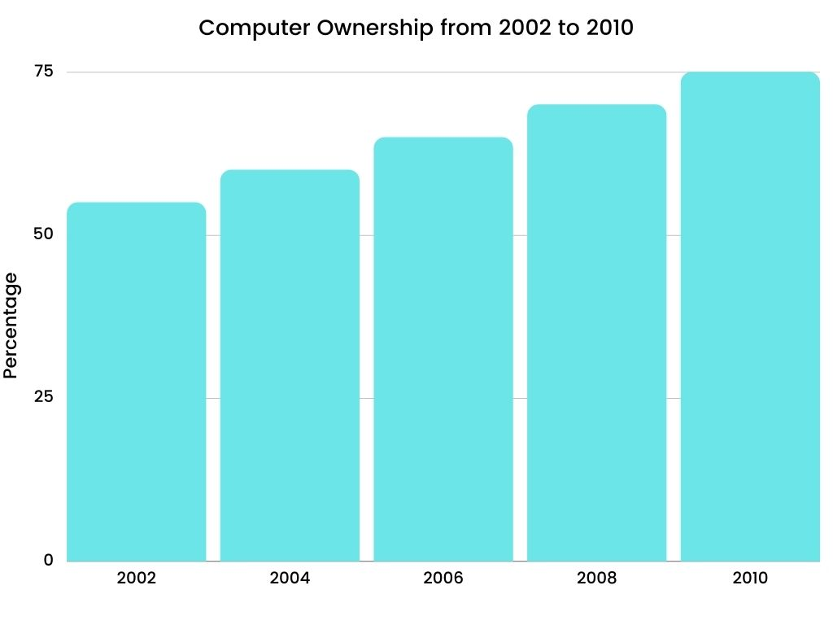

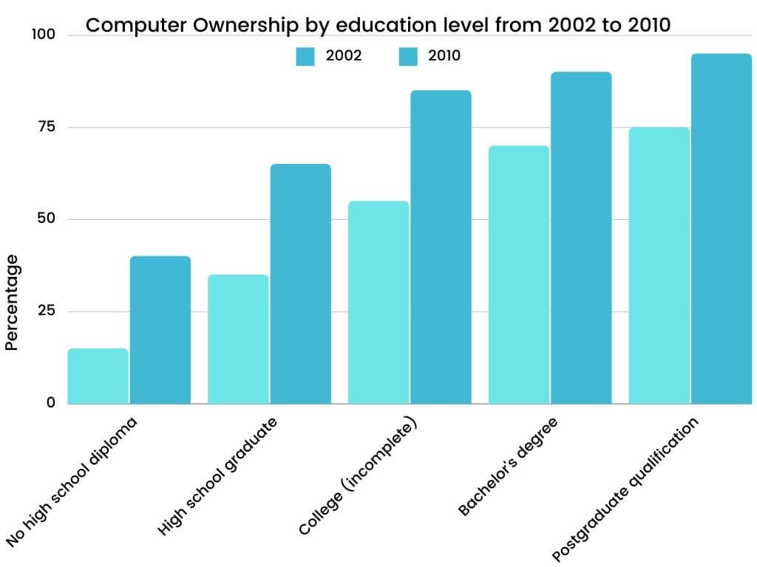

**Assignment 1 A guided Task 1 writing exercise. There are 4 parts to this exercise!**

**Study the 2 graphs above and follow the steps and instructions below**

**Before you do this, refer to all class handouts, especially the Task1 model answers!!**

**Exercise 1**

**Introduction: *Paraphrase the title***

***The graphs give information*** *= The graphs compare/show;*

***information about computer ownership*** *= data associated with people who owned computers*

***for the years 2002 and 2010*** *= over eight years/ from 2002 to 2010*

***Begin: The graphs compare….. or The graphs show….***

**Write your introduction here:**

**The graphs compare data associated with people who owned computers and classified ownership by education level from 2002 to 2010.**

**Exercise 2**

***Overview:*** *mention two things:*

*(a) percentage of people who owned computers-increased dramatically*

*(b) ownership increased for all education levels: more highly educated people= higher ownership*

***Use the past tense***

***Begin: It is clear that/ or Overall,***

**Write your overview here:**

**It is clear that the percentage of people who owned computers increased dramatically, and ownership increased for all education levels. Especially in highly educated people, the higher the education, the more ownership.**

**Exercise 3**

***Paragraph 2: (1) Write about the number of people owning computers. Give figures and make comparisons.***

***Begin: Looking at the first graph we can see/ or According to the first chart, etc.***

**Write paragraph 2 here:**

**According to the first chart, the percentage rose gradually from about 52% to 75% over 8 years. Furthermore, it’s easy to compute that the increasing percentage of computer ownership every year was about 3% from 2002 to 2010.**

**Exercise 4**

***Paragraph 3: (1) Talk about the number of people owning computers by education level- make comparisons. Give figures.***

***Begin: Turning to the other chart, According to the second graph, etc.***

**Write paragraph 3 here:**

**Turning to the other chart, computer ownership increased significantly by education level, particularly among those with no high school diploma, where it increased by about 25%. Although the higher education level person occupied more computer ownership, however, the increasing magnitude was less than the lower education level from 2002 to 2010.**